Table-1 : Components & Technologies:

Table-2: Application Characteristics:

References:

Project Design Phase-II Technology Stack (Architecture & Stack)

Date | 31 January 2026
Team ID | LTVIP2026TMIDS24384
Project Name | I Revolution_ A Data-driven Exploration of  Apple's iPhone Impact in India using tableau
Maximum Marks | 4 Marks

Technical Architecture:
The Deliverable shall include the architectural diagram as below and the information as per the table1 & table 2

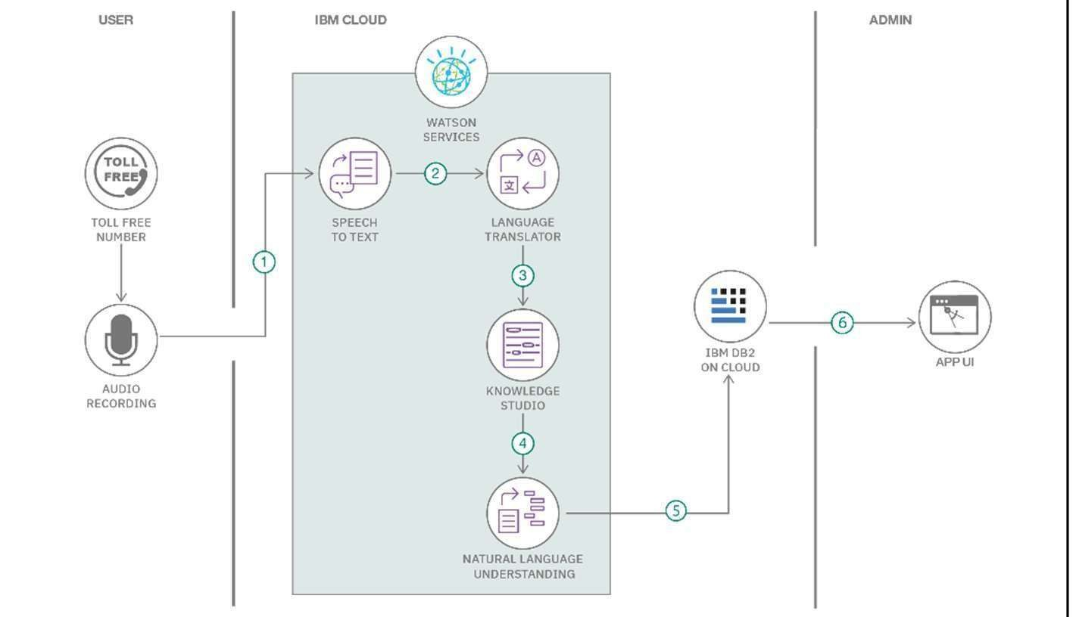
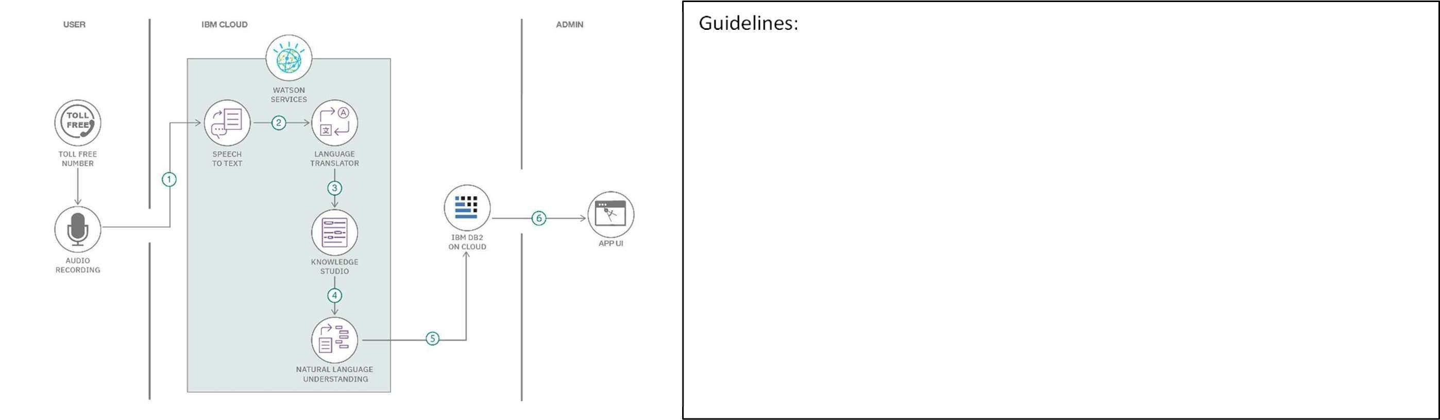

Include all the processes (As an application logic / Technology Block)
Provide infrastructural demarcation (Local / Cloud) Indicate external interfaces (third party API’s etc.) Indicate Data Storage components / services Indicate interface to machine learning models (if applicable)

Table 1:

Component | Tool / Technology | Purpose
Data Source | CSV, JSON files | Raw smartphone sales and specifications data
Visualization | Tableau Desktop | Creating interactive dashboards and stories
Storage | Google Drive / Local System | Storing raw and processed datasets
Collaboration | Google Docs, Slack | Team communication and report writing
Deployment | Tableau Public / Tableau Server | Dashboard sharing and stakeholder access

Table 2: Application Characteristics

S.No | Characteristics | Description | Technology
1 | Open-Source Frameworks | The application uses open datasets and visualization tools to analyze iPhone sales and market trends  in India. Tableau supports integration with open data formats for analytics. | Tableau Desktop, CSV/JSON  data formats
2 | Security  Implementations | The system ensures secure access to dashboards through Tableau Public/Server permissions. Data  files are stored securely and access is controlled at the platform level. | Tableau authentication, Access  control, HTTPS
3 | Scalable Architecture | The architecture supports scalability by handling large datasets and multiple visualizations efficiently  through Tableau’s in-memory engine. | Tableau Hyper Engine
4 | Availability | The dashboards are available online through Tableau Public/Server, enabling access anytime  through a web browser without local installation. | Tableau Public / Tableau Server

S.No | Characteristics | Description | Technology
5 | Performance | Performance is optimized using data extracts, filters, and efficient visual rendering to ensure fast  dashboard loading and smooth interaction. | Tableau Extracts (.hyper),  Caching

